An Applied Evaluation of YOLO11n for Road-Damage Detection with Controlled Class-Imbalance Mitigation and Multi-Mode Deployment
A Project-Based Research Report
Author: Safiya Mirbahar
Institution: Sukkur IBA University, Dadu Campus
Department: Computer Science
Program: Bachelor of Science in Computer Science
Expected Graduation: 2027
Date: 01 September 2026

Abstract
This report describes the construction and evaluation of a road-damage detection system built on the India subset of the RDD2022 road-damage dataset, using the YOLO11n object-detection model. The source data consisted of 1,530 images and 1,530 Pascal VOC XML annotation files covering nine damage classes (D00, D01, D10, D11, D20, D40, D43, D44, D50) and 4,524 annotated objects in total. A custom Python pipeline converted the XML annotations into YOLO-format label files, and the converted labels were checked through visual, structural, and numerical validation before an 80:20 train/validation split (1,224 and 306 images, random seed 42) was created.
A first YOLO11n model was trained for 50 epochs on the unmodified training set (image size 640×640, batch size 16, Tesla T4 GPU). Evaluated on the 306-image validation set, it reached a precision of approximately 0.65, a recall of approximately 0.17, an mAP50 of approximately 0.21, and an mAP50-95 of approximately 0.09. Because the training annotations were dominated by class D40 (3,187 of 4,524 objects) while three classes contained fewer than ten objects each, a second training set of 1,444 images was built using controlled oversampling of the minority classes, while the validation set was left unchanged. Retraining YOLO11n on this balanced set produced a precision of 0.508, a recall of 0.407, an mAP50 of 0.369, and an mAP50-95 of 0.146 on the same validation data — a large gain in recall and mAP50 at some cost to precision. Confusion-matrix inspection showed that missed detections (damage classified as background) remained the largest source of error, particularly for D40.
The trained model was integrated into a local application, first built with Streamlit and later rebuilt with Gradio, supporting image upload, video upload, and live-camera detection with an adjustable confidence threshold, and a video-processing pipeline that re-encodes annotated output through FFmpeg into browser-playable H.264 MP4. The report documents this pipeline end to end, reports the metrics and confusion-matrix findings as recorded, and discusses dataset size and class imbalance as the main factors limiting the current results.
Keywords: road damage detection; object detection; YOLO11n; RDD2022; class imbalance; oversampling; real-time detection; Gradio.

1. Introduction
Cracks, potholes, and other forms of road-surface deterioration are still identified in most places through manual road inspection, a process that is slow, labour-intensive, and dependent on the individual inspector's judgment. Image-based automatic detection of road damage using deep learning has been investigated as an alternative for close to a decade, beginning with datasets such as RDD2018 and its successors, which were collected specifically to support this line of work (Maeda et al., 2018; Arya et al., 2022).
This report documents a project that builds a road-damage detection pipeline around the India subset of the RDD2022 dataset. The project's stated near-term target was real-time pothole detection from a live camera feed; the longer-term goal recorded in the project notes was a full camera → detection → warning → GPS-location pipeline. Only the detection stage — image, video, and live-camera inference using a trained YOLO11n model — was implemented and evaluated in this project. The warning-generation and GPS-location stages described as the final goal were not built, and this report does not claim otherwise.
The work covers four stages: (1) inspection, validation, and Pascal VOC-to-YOLO conversion of the annotated dataset; (2) analysis of class imbalance in the resulting labels and construction of a second, oversampled training set; (3) training and evaluation of YOLO11n on both the original and the oversampled training sets, using a fixed, unmodified validation set; and (4) integration of the trained model into a local image/video/camera application. Each stage, along with the exact figures, parameters, and results recorded during the project, is reported in the sections that follow.

2. Related Work
Automatic road-damage detection using deep learning was established as a research area by Maeda et al. (2018), who introduced an eight-category damage taxonomy based on the Japanese Road Maintenance and Repair Guidebook: two forms of longitudinal crack (D00, D01), two forms of transverse/lateral crack (D10, D11), alligator crack (D20), a combined “other corruption” category covering rutting, bumps, potholes, and separation (D40), crosswalk blur (D43), and white-line blur (D44). This taxonomy was used for the original RDD2018 and RDD2019 datasets, both collected in Japan.
As the dataset was extended to multiple countries, Arya et al. (2022) describe how the RDD2020 and RDD2022 releases dropped the two road-marking categories (D43, D44) from the officially released, multi-country training data, because criteria for judging crosswalk and white-line deterioration vary between countries; the publicly released RDD2022 training set is annotated with four classes — D00, D10, D20, and D40 — across all six countries it covers. Arya et al. (2022) also report that the India portion of the RDD2022 training data contains exactly 3,187 D40 (pothole) instances, a figure that matches the D40 object count used in this project. This match indicates that the annotation set used here corresponds to the India subset of this dataset family, retained at an earlier, more fine-grained annotation stage that still carries the D01, D11, D43, D44, and D50 labels, rather than the four-class scheme used in the official RDD2022 training release.
Class imbalance of this kind — a small number of dominant categories such as D40 or D20 alongside categories with only a handful of examples — is a recurring problem in this dataset family. Salcedo et al. (2022) discuss the unevenness of the RDD-derived category counts directly and, for their own road-damage system, relabel their data around four broader categories rather than the full multi-class taxonomy, specifically to reduce the effect of imbalance. Salcedo et al. (2022) also note that the best-performing submission to the 2020 Global Road Damage Detection Challenge used a YOLOv5-based model ensemble, which is consistent with the wider use of the YOLO family of detectors for this task.
The model used in this project, YOLO11n, is the smallest (“nano”) variant of Ultralytics' YOLO11 family, released in September 2024 as a successor to YOLOv8 with a revised backbone and neck; Ultralytics' own documentation reports higher accuracy than YOLOv8m while using about 22% fewer parameters (Ultralytics, 2024). This project does not introduce a new detection architecture. It applies an existing pretrained YOLO11n model to a specific, imbalanced subset of an existing dataset, and its contribution is the documented preprocessing, balancing, and evaluation pipeline built around that model rather than any change to the underlying architecture.

3. Dataset and Problem Definition
The project used the India subset of the RDD2022 road-damage dataset, referred to in the project notes as the “RDD2022 India pothole D40” data. The dataset consisted of 1,530 JPEG images, each with a corresponding Pascal VOC XML annotation file, giving 1,530 image–annotation pairs with no missing files on either side.
Each XML annotation recorded the image width and height and, for every damage object present in the image, a class name and a bounding box defined by four pixel coordinates: xmin, ymin, xmax, and ymax. A full inspection of all 1,530 XML files found nine distinct damage classes rather than a single “pothole” class, and 4,524 annotated objects in total across the dataset. Table 1 reports the per-class object counts found during this inspection.
Class | Objects | Share of total
D00 | 471 | 10.4%
D01 | 27 | 0.6%
D10 | 23 | 0.5%
D11 | 7 | 0.2%
D20 | 645 | 14.3%
D40 | 3,187 | 70.4%
D43 | 5 | 0.1%
D44 | 151 | 3.3%
D50 | 8 | 0.2%
Total | 4,524 | 100.0%
Table 1. Per-class object counts across all 1,530 annotated images in the dataset.
D40 alone accounted for 3,187 of the 4,524 objects (70.4%), while D43, D11, and D50 accounted for only 5, 7, and 8 objects respectively. This distribution is consistent with the class definitions reported by Maeda et al. (2018) for the original eight-category taxonomy — D00/D01 as longitudinal cracks, D10/D11 as transverse cracks, D20 as alligator crack, D40 as a combined rutting/bump/pothole/separation category, and D43/D44 as road-marking blur — with D50 present as an additional class in this dataset that is not part of the eight-category scheme described in that source.
Information required: the exact official definition of class D50 in this dataset was not confirmed against a verifiable published source during this report's preparation and should be added once the original RDD2022 India annotation documentation is consulted.
For YOLO-format training, each class name was mapped to a numerical class ID, shown in Table 2. This mapping was fixed for the remainder of the project and used consistently in the conversion script, the dataset configuration file, and the evaluation output.
Class name | YOLO class ID
D00 | 0
D01 | 1
D10 | 2
D11 | 3
D20 | 4
D40 | 5
D43 | 6
D44 | 7
D50 | 8
Table 2. Class-name-to-class-ID mapping used for YOLO annotation conversion.
Given this distribution, the problem addressed by the project was defined as: train an object-detection model capable of localizing and classifying road-damage instances of these nine types in images, video, and live-camera frames, using a dataset in which one class (D40) is heavily overrepresented and several classes have only single-digit object counts.

4. Data Preprocessing and Annotation Conversion

4.1 Pascal VOC to YOLO conversion
YOLO training requires one label file per image, with each line giving a class ID and a bounding box normalized to the [0, 1] range in the form class_id x_center y_center width height. Because the source annotations were in Pascal VOC XML, a conversion step was necessary before training could begin.
A Python script, convert_voc_to_yolo.py, was written for this purpose using pathlib for file and directory handling and xml.etree.ElementTree for parsing the XML files. For each image, the script read the stored image width and height, then, for every annotated object, read the class name and the xmin/ymin/xmax/ymax bounding box, computed the box center and dimensions, normalized these values by the image width and height, and looked up the class name in the mapping shown in Table 2 to obtain a numerical class ID.
For example, the pothole (D40) annotation for image India_000005.jpg, with bounding box xmin=20, ymin=473, xmax=368, ymax=576, was converted to the YOLO line:
5 0.269444 0.728472 0.483333 0.143056
An early version of the converter wrote each object's label to its output file using write mode ("w") from inside the per-object loop, which meant that for images with more than one annotated object, only the last object's label survived in the file. This was identified before the full dataset was converted and corrected by first collecting all objects belonging to one image into a list and writing them together to a single output file.
The converter also included a set of data-integrity checks: detection of unknown class names not present in the class mapping, detection of missing bounding-box fields, detection of invalid (non-positive) bounding-box dimensions, validation that normalized coordinates fell inside [0, 1], exception handling for malformed XML files, and reporting of how many files were converted versus skipped. Running the corrected converter over the full dataset produced the following result:
- XML files processed: 1,530
- Successfully converted: 1,530
- Skipped due to errors: 0

4.2 Visual validation of the conversion
Because a script completing without errors does not by itself confirm that the output is correct, the converted YOLO coordinates were converted back from normalized values to pixel coordinates and drawn on the original images using Pillow, and compared against the original Pascal VOC bounding box for the same object. The bounding box reconstructed from the YOLO label matched the location of the original Pascal VOC annotation, which was taken as visual confirmation that the coordinate transformation and normalization were implemented correctly.

5. Dataset Splitting and Structural Validation

5.1 Train/validation split
After conversion, the dataset (1,530 images, 1,530 YOLO label files, no missing pairs) was divided into training and validation subsets using an 80:20 ratio: 1,224 images (80%) for training and 306 images (20%) for validation. Images were shuffled before splitting to avoid an ordering bias, using Python's random module, and a fixed random seed of 42 was used so that the same split could be reproduced. Corresponding image and label files were kept together throughout the split using shutil to copy (not move) files into the new directory structure, so that the original dataset and its Pascal VOC annotations remained untouched.
The resulting YOLO dataset directory followed the structure:
dataset/images/train, dataset/images/val, dataset/labels/train, dataset/labels/val, plus a data.yaml configuration file.
The data.yaml file specified the training and validation image paths, the number of classes (9), and the class-ID-to-name mapping given in Table 2, so that the training framework did not require hard-coded paths or class definitions in code.

5.2 Structural and correspondence validation
A separate validation script checked that every image in each subset had a corresponding YOLO label file, confirming 1,224 image–label pairs in the training set and 306 pairs in the validation set, with none missing on either side. A second validation pass checked the content of every YOLO label file for five required fields per line, valid numerical values, class IDs within the defined range, center coordinates within [0, 1], and strictly positive width and height values. This pass reported zero invalid labels in either subset.
Taken together, the preprocessing pipeline for this project consisted of the following validation stages, applied in sequence: XML annotation inspection, class-name verification, coordinate conversion, YOLO annotation generation, visual bounding-box validation, image–label correspondence validation, train/validation split validation, and final YOLO-label structural and numerical validation.

5.3 Class distribution after the split
The 4,524 annotated objects in the dataset were distributed across the two subsets as shown in Table 3. All objects were preserved by the split: 3,620 in the training subset and 904 in the validation subset, summing to the original total of 4,524.
Class | Train | Validation | Total
D00 | 373 | 98 | 471
D01 | 23 | 4 | 27
D10 | 20 | 3 | 23
D11 | 6 | 1 | 7
D20 | 499 | 146 | 645
D40 | 2,567 | 620 | 3,187
D43 | 4 | 1 | 5
D44 | 121 | 30 | 151
D50 | 7 | 1 | 8
Total | 3,620 | 904 | 4,524
Table 3. Object counts per class after the 80:20 train/validation split.
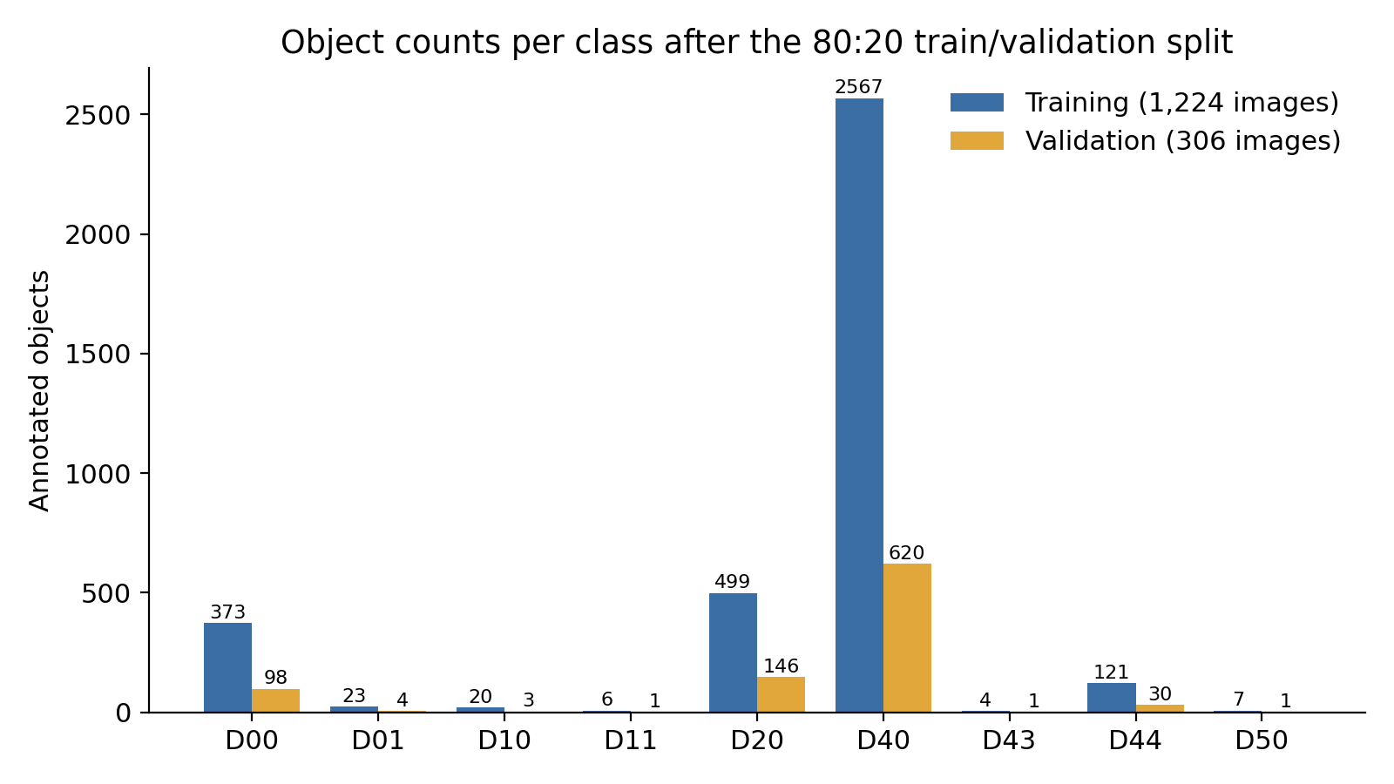
Figure 1. Object counts per class in the training set (1,224 images) and validation set (306 images), plotted from Table 3.
Several classes have very low validation counts under this split — D11, D43, and D50 each have only a single validation object, and D01 and D10 have four and three respectively. Precision and recall computed for these classes from so few examples are statistically unstable, and the project notes flag this explicitly as a limitation to keep in mind when interpreting per-class results in Section 9.

6. Class Imbalance and the Balanced Training Set

6.1 Imbalance analysis
The training-set counts in Table 3 show that class D40 accounted for 2,567 of the 3,620 training objects (70.9%), while D43, D11, and D50 accounted for 4, 6, and 7 objects respectively. The project notes also record that rare-class objects tended to co-occur in images that also contained D40 objects: images containing D11, D43, or D50 were frequently found to also contain a D40 annotation. This observation ruled out a simple duplication of minority-class images as a balancing strategy, since duplicating those images would also increase the exposure of the already-dominant D40 class.

6.2 Controlled oversampling strategy
Rather than forcing every class to reach the same object count as D40 — which the project notes describe as likely to cause excessive repetition and overfitting on a small set of images — a controlled oversampling approach was used. Minority classes were identified as D01, D10, D11, D43, D50, and D44, and a target number of additional image occurrences was set individually for each:
Minority class | Target image occurrences added
D01 | 50
D10 | 50
D11 | 40
D43 | 40
D50 | 40
D44 | 150
Table 4. Target image-occurrence counts used for controlled oversampling of minority classes.
Copies of the selected minority-class images and their matching YOLO label files were added to a new training directory, separate from the original training set. The original 1,224-image training set, and the 306-image validation set, were left unmodified; only this new, separate balanced_train directory was affected. The resulting balanced training set contained 1,444 images, versus 1,224 in the original training set.
The project notes explain the reasoning for copying label–image pairs rather than applying geometric image transformations directly: a geometric transformation (rotation, cropping, scaling) changes bounding-box coordinates, and manually transforming images without correspondingly transforming their labels would corrupt the annotations. To avoid this risk, minority-class images were duplicated as-is, leaving YOLO's own training-time augmentation (applied identically by the Ultralytics training pipeline to both the original and the balanced runs) as the source of image-level variation during training.

6.3 Class distribution after balancing
Object counts in the balanced training set, compared with the original full-dataset counts, are shown in Table 5 and Figure 2. The balancing step increased the object counts of every targeted minority class — for example, D43 rose from 5 to 40 objects and D01 rose from 27 to 115 — without equalizing all classes to the size of D40, which itself decreased slightly from 3,187 to 2,895 objects because the balanced set is smaller in scope than the full original dataset’s object count for that class.
Class | Original dataset (objects) | Balanced training set (objects)
D00 | 471 | 418
D01 | 27 | 115
D10 | 23 | 53
D11 | 7 | 63
D20 | 645 | 565
D40 | 3,187 | 2,895
D43 | 5 | 40
D44 | 151 | 198
D50 | 8 | 45
Table 5. Object counts before and after controlled oversampling of the training data.
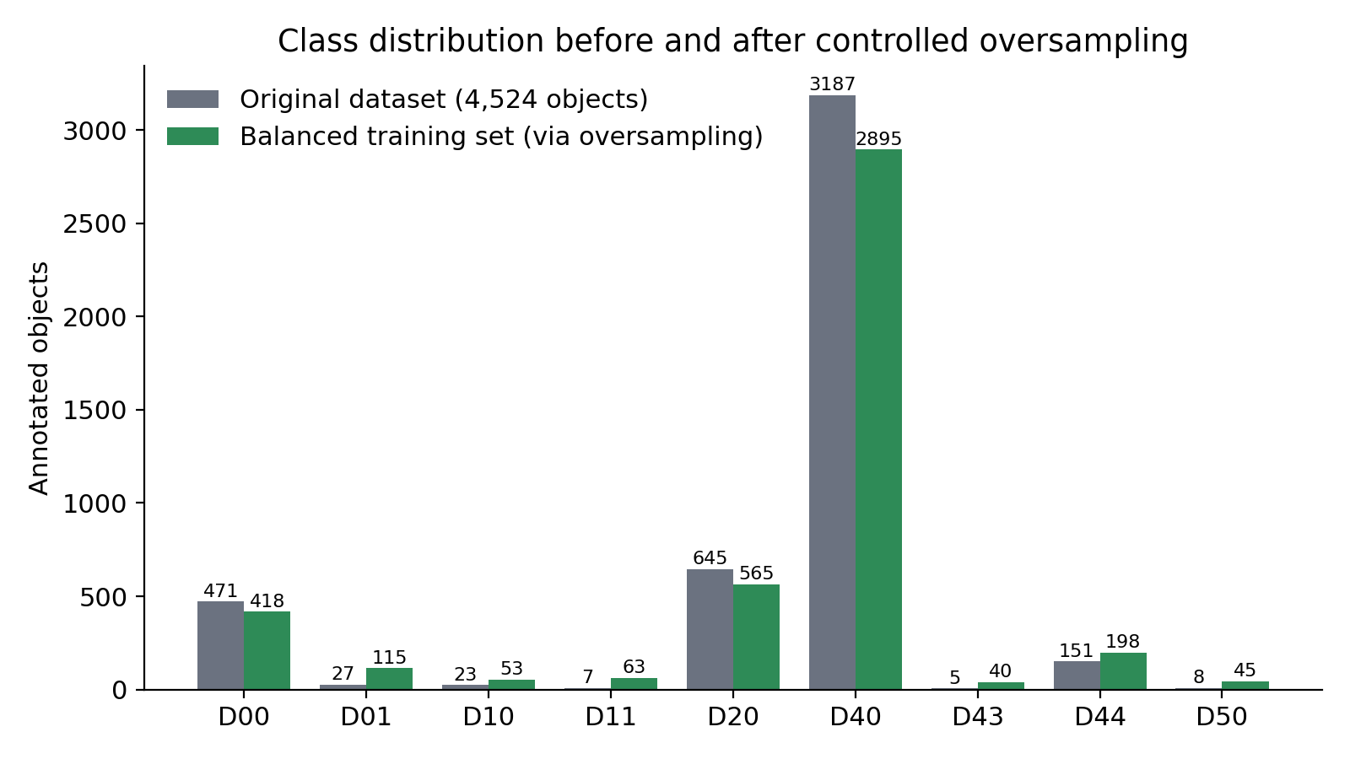
Figure 2. Class distribution before balancing (original full dataset) and after controlled oversampling of the training set, plotted from Table 5.
The dataset remained imbalanced after this step — D40 was still the largest class by a wide margin — but the exposure of the rarest classes during training increased substantially. A new data.yaml pointed the training path at the balanced training images while keeping the validation path unchanged, at the original 306-image validation set, so that the two trained models (Section 8) could be compared fairly on identical, unmodified evaluation data.

7. Model and Training Configuration

7.1 Hardware and training environment
The local development machine was checked for GPU availability and was found to have an Intel Iris Xe integrated graphics processor with no NVIDIA CUDA-capable GPU; nvidia-smi was unavailable. Because CPU-based training was expected to be considerably slower than GPU-based training for a deep object-detection model, model training was moved to Google Colab, which provided a Tesla T4 GPU. The verified Colab training environment used PyTorch 2.11.0 built with CUDA 12.8, with CUDA availability confirmed as True, and the Ultralytics package for the YOLO training and inference implementation.
Dataset preparation, annotation conversion, validation, and the final application were developed locally in VS Code; model training and evaluation were carried out in Google Colab; the resulting trained weights (best.pt) were downloaded from Colab and loaded into the local application for inference. Information required: the exact CPU model, system RAM, and operating system of the local development machine were not recorded in the project notes beyond the GPU information above.

7.2 Model selection
YOLO11n — the nano-sized variant of the Ultralytics YOLO11 family — was selected as the model for this project. The project notes give three reasons for this choice: the project's real-time detection requirement, the value of establishing a fast, computationally efficient baseline before testing larger model variants, and the model's suitability for eventual deployment on relatively limited hardware. No larger YOLO11 variant (s, m, l, or x) was trained or evaluated in this project.
The model was initialized from Ultralytics' pretrained yolo11n.pt weights, originally trained for 80 object classes. Loading this checkpoint against the project's 9-class data.yaml caused Ultralytics to automatically replace the detection head, reported in the training log as “Overriding model.yaml nc=80 with nc=9.”

7.3 Training configuration
Two training runs (referred to in this report as the baseline and balanced experiments) were carried out, both using YOLO11n on the Tesla T4 GPU with the following shared configuration:
Parameter | Value
Model | YOLO11n (pretrained yolo11n.pt)
Epochs | 50
Image size | 640 × 640
Batch size | 16
GPU | Tesla T4 (Google Colab)
Optimizer | AdamW
Pretrained weights | Yes
Random seed | 42
Table 6. Shared YOLO11n training configuration used for both the baseline and balanced experiments, as recorded in the project notes.
Information required: the project notes state the optimizer (AdamW) and random seed (42) explicitly for the balanced-dataset training run; the corresponding baseline-run log entry lists model, epochs, image size, batch size, and GPU but does not separately restate the optimizer and seed. Table 6 assumes these two settings were the same for both runs, since Ultralytics uses AdamW and a fixed seed as part of its standard training defaults for this workflow; this assumption should be confirmed against the original Colab notebook before submission.

7.4 The two experiments
Experiment 1 (baseline) trained YOLO11n on the original, unmodified training set of 1,224 images, evaluated on the 306-image validation set. Experiment 2 (balanced) trained YOLO11n, with the same configuration, on the 1,444-image oversampled training set described in Section 6, evaluated on the same, unchanged 306-image validation set. Keeping the validation set identical across both experiments was a deliberate methodological choice recorded in the project notes, made specifically so that the two trained models could be compared on the same evaluation data.

8. Results and Evaluation

8.1 Baseline model (Experiment 1)
The baseline YOLO11n model completed all 50 training epochs on the original 1,224-image training set. Training and validation losses were reported to decrease over the course of training, which was taken as evidence that the model was learning from the data. The best checkpoint from this run, selected according to Ultralytics' own training/validation criteria, was saved as best.pt.
Two separate evaluation runs of this baseline model against the 306-image, 904-object validation set are recorded in the project notes, with slightly different reported values:
Source in project notes | Precision | Recall | mAP50 | mAP50-95
Initial training-run output | 0.649 | 0.172 | 0.210 | 0.0919
Separate model.val() evaluation run | 0.655 | 0.174 | 0.208 | 0.091
Table 7. Baseline YOLO11n results as recorded on two separate occasions in the project notes. The two rows describe the same model evaluated on the same 306-image validation set; the small differences (≤ 0.006 on any metric) likely reflect rounding or minor run-to-run variation rather than two different models.
Precision was substantially higher than recall in both readings (roughly 0.65 vs 0.17), meaning the baseline model's positive predictions were usually correct, but the model missed a large share of the actual damage present in the validation images. D40, the majority class, performed best among the major classes, followed by D20; several classes with very few validation examples produced unreliable results that should not be interpreted as meaningful standalone performance figures.

8.2 Balanced model (Experiment 2)
The second YOLO11n model, trained on the 1,444-image balanced training set with the configuration in Table 6, was evaluated on the same 306-image, 904-object validation set. Its best checkpoint, saved at road_damage_balanced/weights/best.pt (with the final-epoch weights saved separately as last.pt), produced the following overall results:
Metric | Result
Precision | 0.508
Recall | 0.407
mAP@50 | 0.369
mAP@50-95 | 0.146
Table 8. Overall evaluation results for the balanced YOLO11n model on the 306-image validation set.
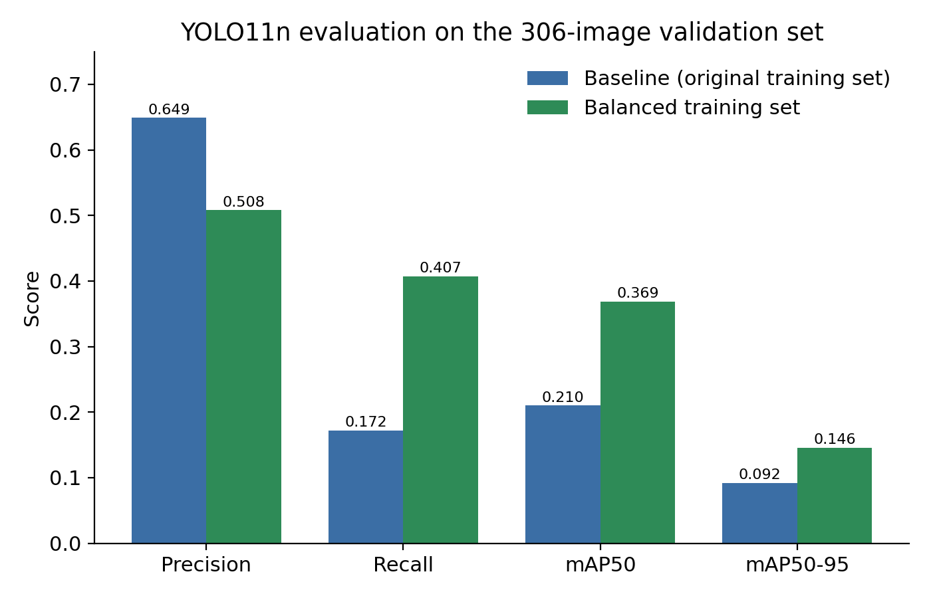
Figure 3. Baseline versus balanced-model evaluation metrics on the same 306-image validation set (values from Tables 7 and 8, using the initial training-run baseline row).
Relative to the baseline, the balanced model's recall more than doubled (0.172 → 0.407) and mAP50 increased from about 0.21 to 0.369, while precision fell from about 0.65 to 0.508. This pattern — higher recall and mAP at the cost of some precision — is consistent with a model that, after training on a set with more exposure to minority classes, produces more positive detections overall, some of which are incorrect, but that also finds substantially more of the actual damage present in the validation images.

8.3 Per-class results for the balanced model
Per-class mAP50 values recorded for the balanced model varied considerably by class. D40, the majority class, reached an mAP50 of approximately 0.499, and D20 reached approximately 0.419. D01 reached a notably high mAP50 of approximately 0.895, but this value is based on only 4 validation instances of that class and should not be read as reliable evidence of strong D01 performance. D10 was reported as essentially unsuccessful, and D11, D43, and D50 had validation counts too small (one instance each, in the case of D11 and D50, from Table 3) to support any dependable per-class conclusion.
The project notes are explicit that these per-class numbers should not be used to claim the balanced model is highly accurate overall: performance is concentrated on the classes with reasonable validation support (D40, D20), while figures for the rarest classes reflect statistical noise from very small sample sizes rather than demonstrated detection capability.

8.4 Confusion matrix analysis
The confusion matrix produced for the balanced model showed that the largest single source of error was damage being classified as background — that is, missed detections rather than misclassifications between damage types. The recorded background-confusion counts were:
- background ← D40: 285 instances
- background ← D20: 58 instances
- background ← D00: 71 instances
- background ← D44: 22 instances
The confusion matrix also showed confusion between visually similar damage categories, notably D20 ↔ D40 and D00 ↔ D20/D40. Given that D20 (alligator crack), D40 (rutting/bump/pothole/separation), and D00 (longitudinal crack) can share visual characteristics such as irregular dark regions and surface texture changes, this pattern is consistent with genuine visual ambiguity between categories, rather than with a random or unexplained error pattern.

9. Discussion
The results in Section 8 point to the dataset, rather than the number of training epochs or the choice of model size, as the main limitation on performance in this project. The project notes state this conclusion directly: several validation classes contained only one to four objects (D11: 1, D43: 1, D50: 1, D10: 3, D01: 4), a sample size too small to draw a reliable conclusion about the model's actual performance on those categories, however the raw metric is calculated. The decision recorded in the project notes was therefore not to keep adjusting the model purely to chase a higher aggregate score, but to document this limitation directly.
The class-imbalance mitigation applied here — controlled oversampling of minority-class images within the training set only — produced a clear net improvement in recall and mAP50 relative to the baseline, at a real cost in precision. Whether this trade-off is acceptable depends on the intended use of the system: for a use case where missing real damage is more costly than occasionally flagging a false positive (for example, an initial screening pass that a human later reviews), the balanced model's higher recall would generally be preferable to the baseline's higher precision; for a use case where false alarms carry a high cost, the trade-off would need to be reconsidered, for instance by tuning the confidence threshold rather than by relying on the balancing step alone.
The confusion-matrix pattern of background misclassification for the majority class D40 (285 missed detections) indicates that even the class with the most training data was still frequently missed by the balanced model, which suggests that the absolute size of the dataset — 1,530 source images in total — may itself be a limiting factor, independent of how the existing images are balanced across classes. The additional confusion observed between D20, D40, and D00 is consistent with these categories sharing visual characteristics that make them genuinely difficult to separate from bounding-box-level image data alone, a difficulty also implicit in Maeda et al.'s (2018) original decision to group rutting, bumps, potholes, and separation into the single D40 category rather than treating them as visually distinct classes.
The application layer built around the trained model (Section 10) functioned as intended — it successfully produced image, video, and live-camera detections — but a working application should not be read as evidence of a highly accurate underlying model. The project notes state this distinction explicitly: the completed prototype and the model's measured accuracy are two separate things, and the confusion-matrix and recall figures reported here should be read alongside, not in place of, the description of the application in Section 10.

10. Real-Time Road Damage Detection Application

10.1 Model integration
The trained best.pt weights from the balanced-model run were moved from Google Colab into the local project, under models/best.pt. The application code located this file using a path built with pathlib relative to the application script's own location (ROOT = Path(__file__).resolve().parent.parent; MODEL_PATH = ROOT / "models" / "best.pt"), so that the model could be found regardless of the working directory the application was launched from. The model was loaded with YOLO(str(MODEL_PATH)) from the Ultralytics package.

10.2 First interface: Streamlit
The first version of the application was built with Streamlit and provided three sections: Upload Image, Upload Video, and Camera Capture. The model object was cached with @st.cache_resource so that it was loaded once rather than being reloaded on every Streamlit rerun. OpenCV was used for frame-by-frame video processing, NumPy for converting images to arrays for the model, and Pillow for opening uploaded images.
During testing of this version, an uploaded pothole image was not detected at the application's default confidence threshold of 0.25. As a diagnostic step, the threshold was temporarily lowered to 0.05 to check whether the model was producing detections that were being filtered out by the confidence cutoff rather than not detecting the damage at all. This diagnostic change did improve visible detections in the Streamlit interface, though the project notes note explicitly that a lower confidence threshold can also increase false positives, and that 0.05 was not necessarily intended as the system's final operating threshold.
The Streamlit application's camera feature used Streamlit's built-in st.camera_input(), which captures a single still frame per user interaction rather than continuously processing a live video stream; the project notes flag this explicitly as not true continuous real-time detection.

10.3 Final interface: Gradio
The application was subsequently rebuilt using Gradio, with the codebase reorganized into separate modules — app.py, detector.py, video_processor.py, and gradio_app.py — and three detection modes were implemented:
- Image Detection: an uploaded image is passed to the YOLO11n model, and the result is displayed with bounding boxes, class labels, and confidence scores.
- Video Detection: an uploaded video is processed frame by frame with OpenCV, each frame is passed through the model, and the annotated frames are reassembled into a video.
- Live Camera Detection: the device webcam is used as an input source for detection, replacing the single-shot capture used in the earlier Streamlit version.
The Gradio interface also exposed a configurable confidence-threshold control, allowing detection sensitivity to be adjusted directly from the UI rather than only in code.

10.4 Video pipeline and playback fix
An early version of the video-detection pipeline produced processed output that could not be played back, even though detection itself was confirmed to be working: a prior run of the detector reported 553 processed frames and 204 total detections. The problem was isolated to the video-encoding step after detection, rather than to the detection step itself. The project's fix was to write frames using OpenCV into an intermediate video, then convert that intermediate output into a browser-compatible H.264 MP4 using FFmpeg, accessed through the imageio-ffmpeg Python package, and to save the final processed video into the project's own results/ directory rather than relying on a temporary directory that might be cleared.

10.5 Final project structure and technology summary
The completed local project used the following directory layout:
Road_Damage_Detection/ app/ (app.py, detector.py, video_processor.py, gradio_app.py) dataset/ (data.yaml, images/train, images/val, labels/train, labels/val) models/ (best.pt) notebooks/ results/ (annotated_video.mp4) src/ (analyze_distribution.py, check_classes.py, check_dataset.py, check_environment.py, convert_voc_to_yolo.py, inspect_dataset.py, read_annotation.py, split_dataset.py, test_environment.py, validate_split.py, validate_yolo_labels.py, visualize_annotation.py, visualize_yolo.py) explanation.txt requirements.txt
Technology | Role in the project
Python | Main programming language
YOLO11 / Ultralytics | Model training, evaluation, and inference
PyTorch | Underlying deep-learning framework for YOLO11
OpenCV | Reading and processing video frames
NumPy | Converting images/frames into arrays for the model
Pillow (PIL) | Opening and drawing on images; loading uploaded images
lxml / xml.etree.ElementTree | Reading Pascal VOC XML annotations
pathlib | Managing project and dataset file paths
Streamlit | First version of the detection user interface
Gradio | Final version of the detection user interface
FFmpeg / imageio-ffmpeg | Converting processed video to browser-compatible H.264 MP4
tempfile | Temporary storage of uploaded videos during processing
Matplotlib / Pandas | Data analysis and visualization during dataset preparation
Table 9. Technologies and libraries used across the dataset-preparation and application-development stages of the project.
Information required: no frames-per-second, end-to-end latency, or other quantitative real-time-performance measurement for the live-camera or video pipeline is recorded in the project notes; this report therefore does not report a specific real-time speed figure, and one should be measured and added if real-time performance claims are needed.

11. Limitations
- Dataset scale: the underlying dataset contains only 1,530 source images and 4,524 annotated objects, which is small relative to typical modern object-detection training sets, and this limits how much any preprocessing or balancing strategy can improve results.
- Severe class imbalance: even after controlled oversampling, D40 remains the dominant class by a wide margin, and D43, D11, and D50 remain small in absolute terms (Table 5).
- Unreliable per-class validation metrics: several classes have one to four objects in the 306-image validation set, so per-class precision, recall, and mAP figures for these classes (D11, D43, D50, D10, D01) should not be treated as statistically meaningful on their own.
- Missed detections dominate the error pattern: the confusion matrix shows that background misclassification, i.e., real damage not being detected at all, was the largest source of error even for the majority class D40, indicating that recall remains a core weakness of the balanced model despite its improvement over the baseline.
- Precision/recall trade-off from balancing: the balancing strategy improved recall and mAP50 substantially but reduced precision from about 0.65 to 0.508, which has not been further tuned (for example via confidence-threshold adjustment) in this project.
- No measured real-time performance: FPS, inference latency, and any end-to-end system delay for the live-camera and video modes were not measured or recorded, so no claim about real-time speed is made in this report.
- Warning/GPS pipeline not implemented: the project's stated final goal of a camera → detection → warning → GPS-location pipeline was not built; only the detection stage was completed.
- Confidence threshold set diagnostically: the working confidence threshold of 0.05 used during Streamlit testing was adopted to diagnose whether detections were being filtered, not selected through a systematic threshold-tuning study, and the Gradio version's default operating threshold is user-adjustable rather than fixed by a documented optimization process.
- Deployment environment: the model was trained on a cloud GPU (Tesla T4) and run locally on a machine without a dedicated GPU; no benchmarking of inference speed on the actual local (Intel Iris Xe) hardware is recorded.

12. Future Work
The limitations identified above suggest several directions that could reasonably follow from this project's findings, though none of the following was implemented or evaluated here.
- Expanding the underlying dataset, particularly for the rarest classes (D11, D43, D50), so that both training and, importantly, validation contain enough examples per class to support statistically meaningful per-class evaluation.
- Systematically tuning the confidence threshold, rather than relying on the diagnostic value used during development, to find an operating point that better balances precision and recall for the intended use case.
- Measuring frames-per-second and end-to-end latency for the live-camera and video-detection modes, to establish whether the system meets real-time requirements on the intended deployment hardware.
- Implementing the warning-generation and GPS-location stages described as the project's longer-term goal, building on the completed detection stage documented in this report.
- Comparing YOLO11n against other Ultralytics YOLO11 sizes (s, m, l, x) to characterize the accuracy/speed trade-off for this specific dataset, since only the nano variant was evaluated here.

13. Conclusion
This project built a complete pipeline for road-damage detection on the India subset of the RDD2022 dataset: Pascal VOC XML annotations for 1,530 images were converted to YOLO format through a validated custom script, an 80:20 train/validation split was created and checked for correspondence and structural correctness, and a YOLO11n model was trained first on the unmodified data and then on a separately built, oversampled training set targeting six minority classes.
The balanced model outperformed the baseline on recall (0.407 vs about 0.17) and mAP50 (0.369 vs about 0.21) at the cost of precision (0.508 vs about 0.65), and confusion-matrix analysis showed that missed detections, rather than misclassification between damage types, remained the dominant error source, including for the majority class D40. These results, together with the very small per-class validation counts for several categories, support the project's own conclusion that dataset size and imbalance — not epoch count or model choice — are the main current limitation.
The trained model was integrated into a working local application supporting image, video, and live-camera detection with an adjustable confidence threshold and a functioning video-export pipeline. This application demonstrates that the trained model can be deployed in an interactive setting, but, consistent with the project's own documentation, its existence is not treated in this report as evidence of high detection accuracy; the two are reported and should be read separately.

Information Required Before Submission
The following items could not be completed accurately from the provided project notes and should be filled in, verified, or measured before this report is submitted anywhere:
- Target-venue formatting requirements (citation style, margins, page limits, etc.), if this report is submitted to a specific journal, conference, or course — none have been applied beyond the general academic formatting used here. Author name and institutional affiliation have been added to the title page.
- The official definition of damage class D50 in the original RDD2022 India annotation source, which was not confirmed against a verifiable published reference during this report's preparation.
- Confirmation of whether the baseline (Experiment 1) training run used the same optimizer (AdamW) and random seed (42) explicitly recorded for the balanced (Experiment 2) run, since the baseline log entry in the project notes does not restate these two settings separately.
- Resolution of the minor numerical discrepancy between the two baseline evaluation readings recorded in the project notes (Table 7): Precision 0.649 vs 0.655, Recall 0.172 vs 0.174, mAP50 0.210 vs 0.208, mAP50-95 0.0919 vs 0.091.
- CPU model, system RAM, and operating system details for the local development machine (only its integrated GPU, Intel Iris Xe Graphics, was recorded).
- Whether a separate held-out test set (as distinct from the validation set) exists; the project notes mention keeping “test data” unchanged in one place but describe only a train/validation split (no separate test split) elsewhere, and this report has treated the 306-image set as validation data throughout.
- Measured frames-per-second and end-to-end latency for the live-camera and video-detection modes, if real-time performance claims are needed for the final submission.
- The exact confidence threshold used in the final, deployed Gradio application (as opposed to the diagnostic 0.05 value used during Streamlit testing), if it differs from the adjustable default.

References
Arya, D., Maeda, H., Ghosh, S. K., Toshniwal, D., & Sekimoto, Y. (2022). RDD2022: A multi-national image dataset for automatic Road Damage Detection. arXiv preprint arXiv:2209.08538. https://arxiv.org/abs/2209.08538
Maeda, H., Sekimoto, Y., Seto, T., Kashiyama, T., & Omata, H. (2018). Road damage detection and classification using deep neural networks with smartphone images. Computer-Aided Civil and Infrastructure Engineering, 33(12), 1127–1141.
Salcedo, E., Jaber, M., & Requena Carrión, J. (2022). A novel road maintenance prioritisation system based on computer vision and crowdsourced reporting. Journal of Sensor and Actuator Networks, 11(1), 15. https://doi.org/10.3390/jsan11010015
Ultralytics. (2024). Ultralytics YOLO11 documentation. https://docs.ultralytics.com/models/yolo11/
Everingham, M., Eslami, S. M. A., Van Gool, L., Williams, C. K. I., Winn, J., & Zisserman, A. (2015). The Pascal Visual Object Classes challenge: A retrospective. International Journal of Computer Vision, 111(1), 98–136.

